**Day 9**

**Soft link**

**Definition**

Soft link is similar to the file shortcut in windows.soft link can be referred as symbolic link or symlink.It has different inode number and the file permission compared to the original file.It contains the path of the original file and not the contains.when the original file removed the link will be inaccessible because it points to non - existent.This is Called the hanging file.soft link can be Create the using following command ln -s source file name and link name

**1.One file Create and insert to soft link excute command to views**

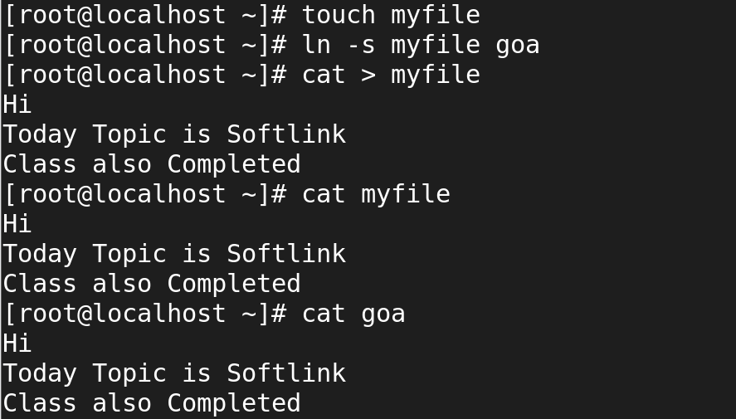

**2.inode has been differents os soft link**

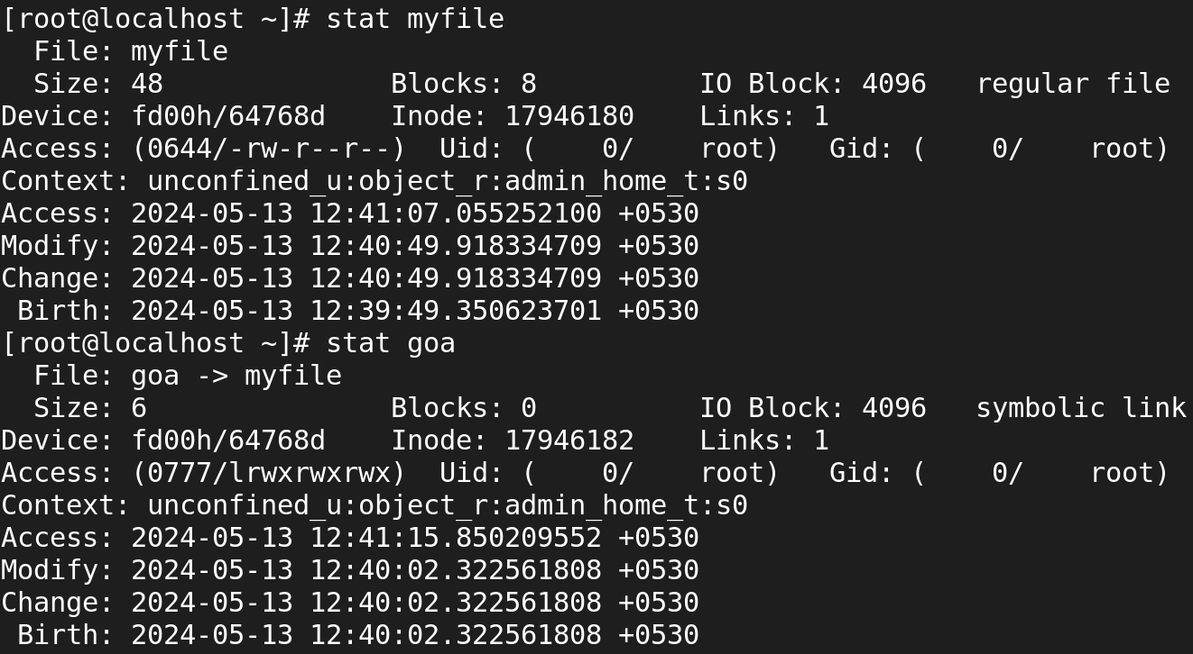

**3.Removing the status will be checking**

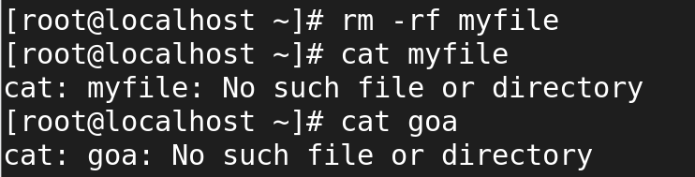

**Hard link**

**Definition**

Mirror copy of the orginal file.It has the same inode number and file permission.It contains the actual contens of the original file nothing happens when the original is removed.Hard link can be using command ln source file name and link file name.

**1.One file Create and insert to hard link excute command to views**

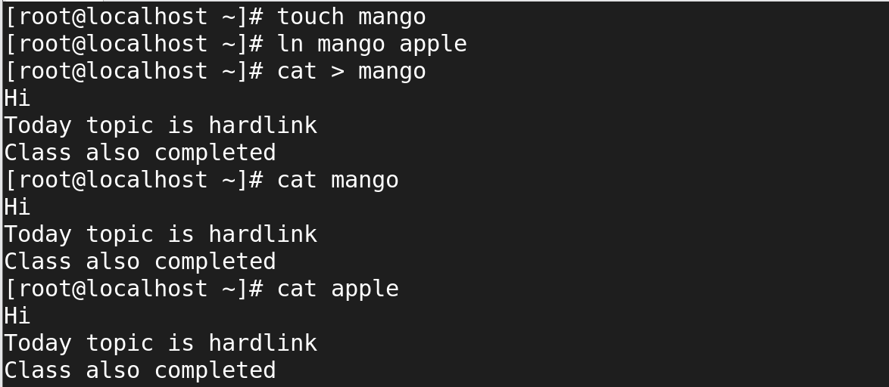**2.idone has been same for hard link**

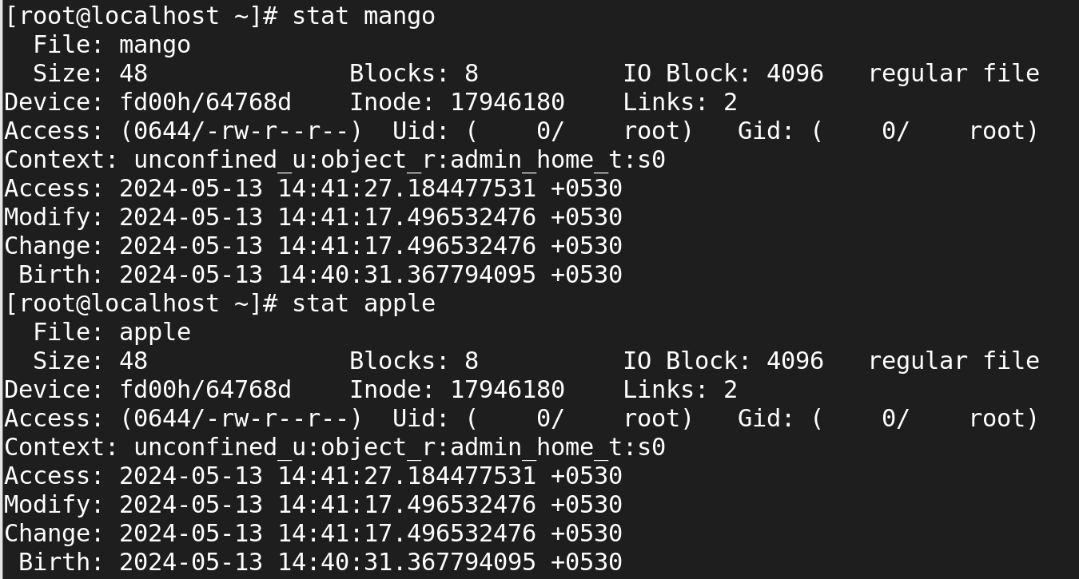

**3.source file will be removing but contains is destination file**

